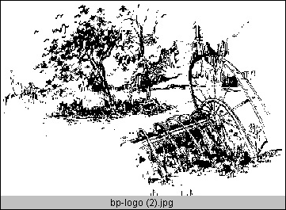BARRON PARK ASSOCIATION

Barron Park Association Member Survey

How frequently do you walk for at least one block along
El Camino Real?
- Every day or almost every day 4
- Several times a month 44
- Only a few times a year 53
- Never, or almost never 44
What are your reasons for not visiting El Camino locations
more often?
- Lack of useful types of stores. 106
- Feel uncomfortable walking along street. Circle all that apply:
Traffic noise 47 Closeness of traffic 42 Wind 7 Dirtiness 43 Other _12 (see comments)
- Uninviting environment (e.g., too much concrete and
traffic, not enough people and landscaping) 63
- Poor pedestrian access from neighborhood. 17
- Difficulty parking (inadequate space, poor access, ...) 28
- Easier to drive to other locations. 27
- Not applicable: unlikely to visit, or unlikely to increase
visits 18
How comfortable do you feel crossing El Camino Real as a
pedestrian?
- I feel comfortable and confident crossing El Camino
Real 50
- I feel comfortable crossing by myself, but would not
cross with children. 12
- I find crossing the street somewhat uncomfortable or
difficult. 32
- I avoid crossing the street as a pedestrian because I
feel uncomfortable and unsafe. 27
- I frequently have to cross the street, even though I feel uncomfortable and unsafe. 3
I feel comfortable letting my children (older than 8) cross
El Camino Real by themselves.
- Yes 23
- No 35
- don't know 26
Where do you predominately shop for groceries
- Shop at store that is convenient on my way home from
work or other errand 24
- Shop at mega-store in neighboring community
(Albertsons, Costco, Safeway, ...) 72
- Shop at nearby Palo Alto store (JJ&F, Mollie Stone,
Safeway-Midtown, ...) 72
- Shop at local specialty food store 15
- Shop at non-Palo Alto specialty food store 14
- Shop periodically at mega-store with many intervening
trips to smaller stores. 27
Have you adapted when you commute/go shopping/run
errands to avoid peak traffic times on El Camino?
- occasionally 26
- often 69
- traffic not a serious problem 16
- traffic less of problem than rescheduling 22

Additional comments about above subjects: ________

############

